Treating Autism EARLY ON

will greatly
benefit the child throughout his or her
life.

Parent Friendly
Hours
&

Providing Full-Time
ABA
Therapy
Center for Autism

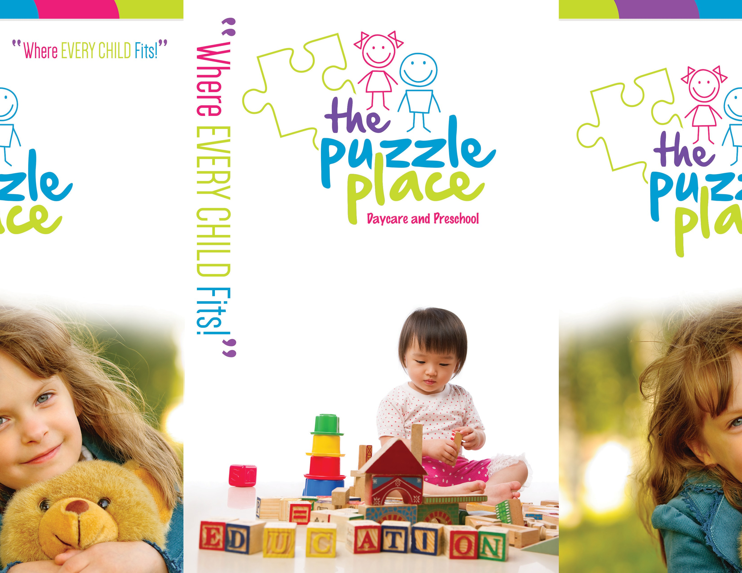

for childre n with autism and re late d disorde rs
// autism
// aspe rge r’s syndrome
// communic ation de lays
// pdd

3425 US 9 North
Freehold, NJ 07228

p 732.994.PUZZ (7899)

w www.ThePuzzlePlace.org
MS Designs / 732.606.7042

What is Applied Behavior Analysis (ABA)?
Behavior analysis is a scientifically validated approach to understanding behavior and how it is affected by the environment. The term “behavior” is used to refer to actions and skills. Any physical or social influence that is changed by the behavior is termed “environment.”
Behavior analysis focuses on the principles that explain how learning takes place. Through decades of research, the field of behavior analysis has developed many techniques for increasing useful behaviors and reducing those that may cause harm or interfere with learning. Applied behavior analysis (ABA) is the use of these techniques and principles to bring about socially significant, meaningful
» Every child gets special treatment
at the Puzzle Place!

» Ratio of staff to child of 1:1
For intensity of therapy

» In house Occupational (OT), Speech (SLP), and Physical Therapists (PT)

» Every child gets an individualized program developed by a BCBA that is incorporated throughout the everyday activities.

SPOTTING EARLY SIGNS OF AUTISM

A Quick Guide for Parents
Social Challenges:
Typically developing infants are social by nature. By 2 to 3
months of age, they gaze at faces, turn towards voices, grasp a finger and even smile. Most children who develop autism have difficulty engaging in standard reciprocal human interactions. By the time these infants are 8 to 10 months old, they exhibit “red flags” such as failure to respond to their names, reduced interest in people and delayed babbling. Many children with autism have difficulty imitating the actions of others, don’t play social games and prefer to play

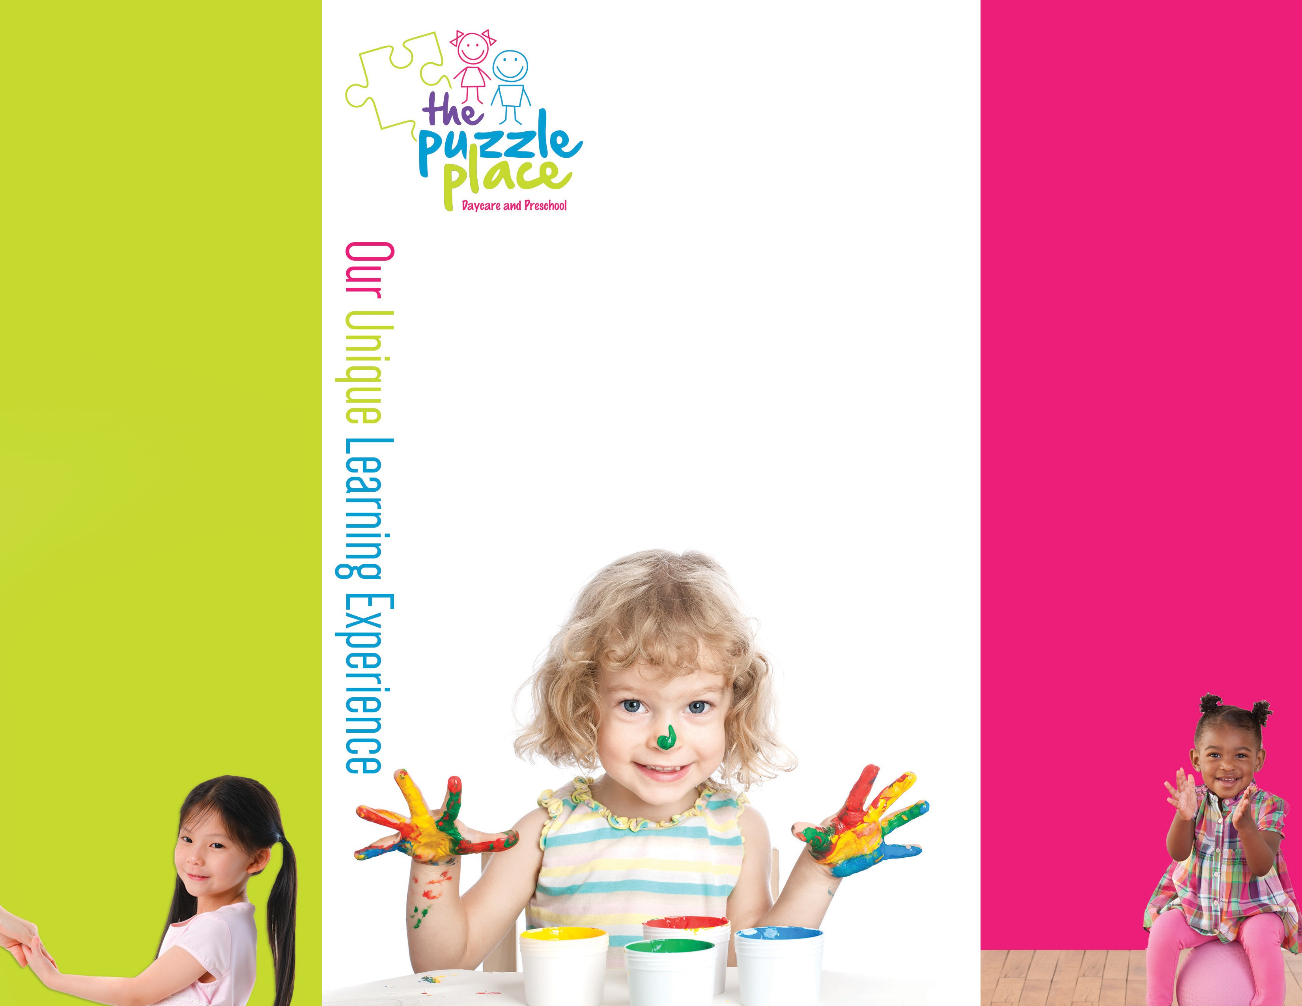and positive change in behavior. A wide variety of ABA techniques have been developed for building useful skills in learners with autism – from toddlers through adulthood. Some ABA therapy sessions involve one-on- one interaction between the behavior analyst and the participant. Group instruction can likewise prove useful. Today, ABA is widely recognized as a safe and effective treatment for autism. It has been endorsed by a number of state and federal agencies, including the U.S. Surgeon General and American Academy of Pediatrics. There have been many peer-reviewed studies that examined the benefits of comprehensive, individualized early intervention ABA programs for children with autism. The program is “comprehensive” in that it addresses a full range of life skills, from communication and sociability to self-care and readiness for school. “Early intervention” refers to programs designed to begin before age 4. An “intensive” program is one that totals 25-40 hours a week for 1-3 years. These programs allow children to learn and practice skills in both structured and unstructured situations. These programs mimic the experiences that typical toddlers experience each day while interacting with their parents and peers. These studies have demonstrated that many children with autism experience significant improvements in learning, reasoning, communication
and adaptability when they participate in high-quality ABA programs.
In general, children who participated in more intensive ABA programs have shown greater improvement than
those who chose less intensive options.

Gross Motor Skills
Physical activities, biking, climbing, swinging,
running, ball play and more!

Fine Motor Skills
Arts & crafts, writing, cutting, beading,
building blocks, coloring and more!

Communication Skills
How to communicate, point, speak,
read and write.

Social Skills
Making eye contact, playskills, immitation
and general social skills.

Adaptive Skills
Feeding and dressing, toilet training and other
functional daily living skills.

Circle Time/Academics
Sorting, shapes, colors, numbers, letters,
science and nature.

Dire c tor:
Ricky Teichman
Board Certified Behavior Analyst
(BCBA)

Our staff is comprised of trained ABA behavior technicians with Registered Behavior Technician (RBT) credential from the BACB.

All techs are supervised and their
work evaluated by the
BCBA regularly.
alone. They may fail to seek comfort or respond to parental
display of affection and other emotions, such as anger, in typical ways.

Communication Difficulties:
By the time he reaches his first birthday, a typically
developing toddler is usually saying a word or two, turns or looks when he hears his name, points to objects he wants or want to show to someone. When offered something that they find distasteful, toddlers can make clear, using vocal sounds or expression, that the answer is “no!”

Repetitive Behaviors:
Repetitive behaviors and/or a tendency to engage in a
restricted range of activities are another early sign of autism. Hand flapping, rocking, jumping and twirling, arranging and rearranging objects and repeating sounds, words or phrases are some common repetitive behaviors. These repetitive behaviors are self-stimulating, like the behavior of wiggling fingers in front of the eyes.

Sensory Processing Problems:
Many children with autism have unusual responses to sensory input and have difficulty processing and integrating stimuli such as sights sounds, smells, tastes, movements and themselves in space. Ordinary stimuli may be experienced
as painful, unpleasant or confusing.

